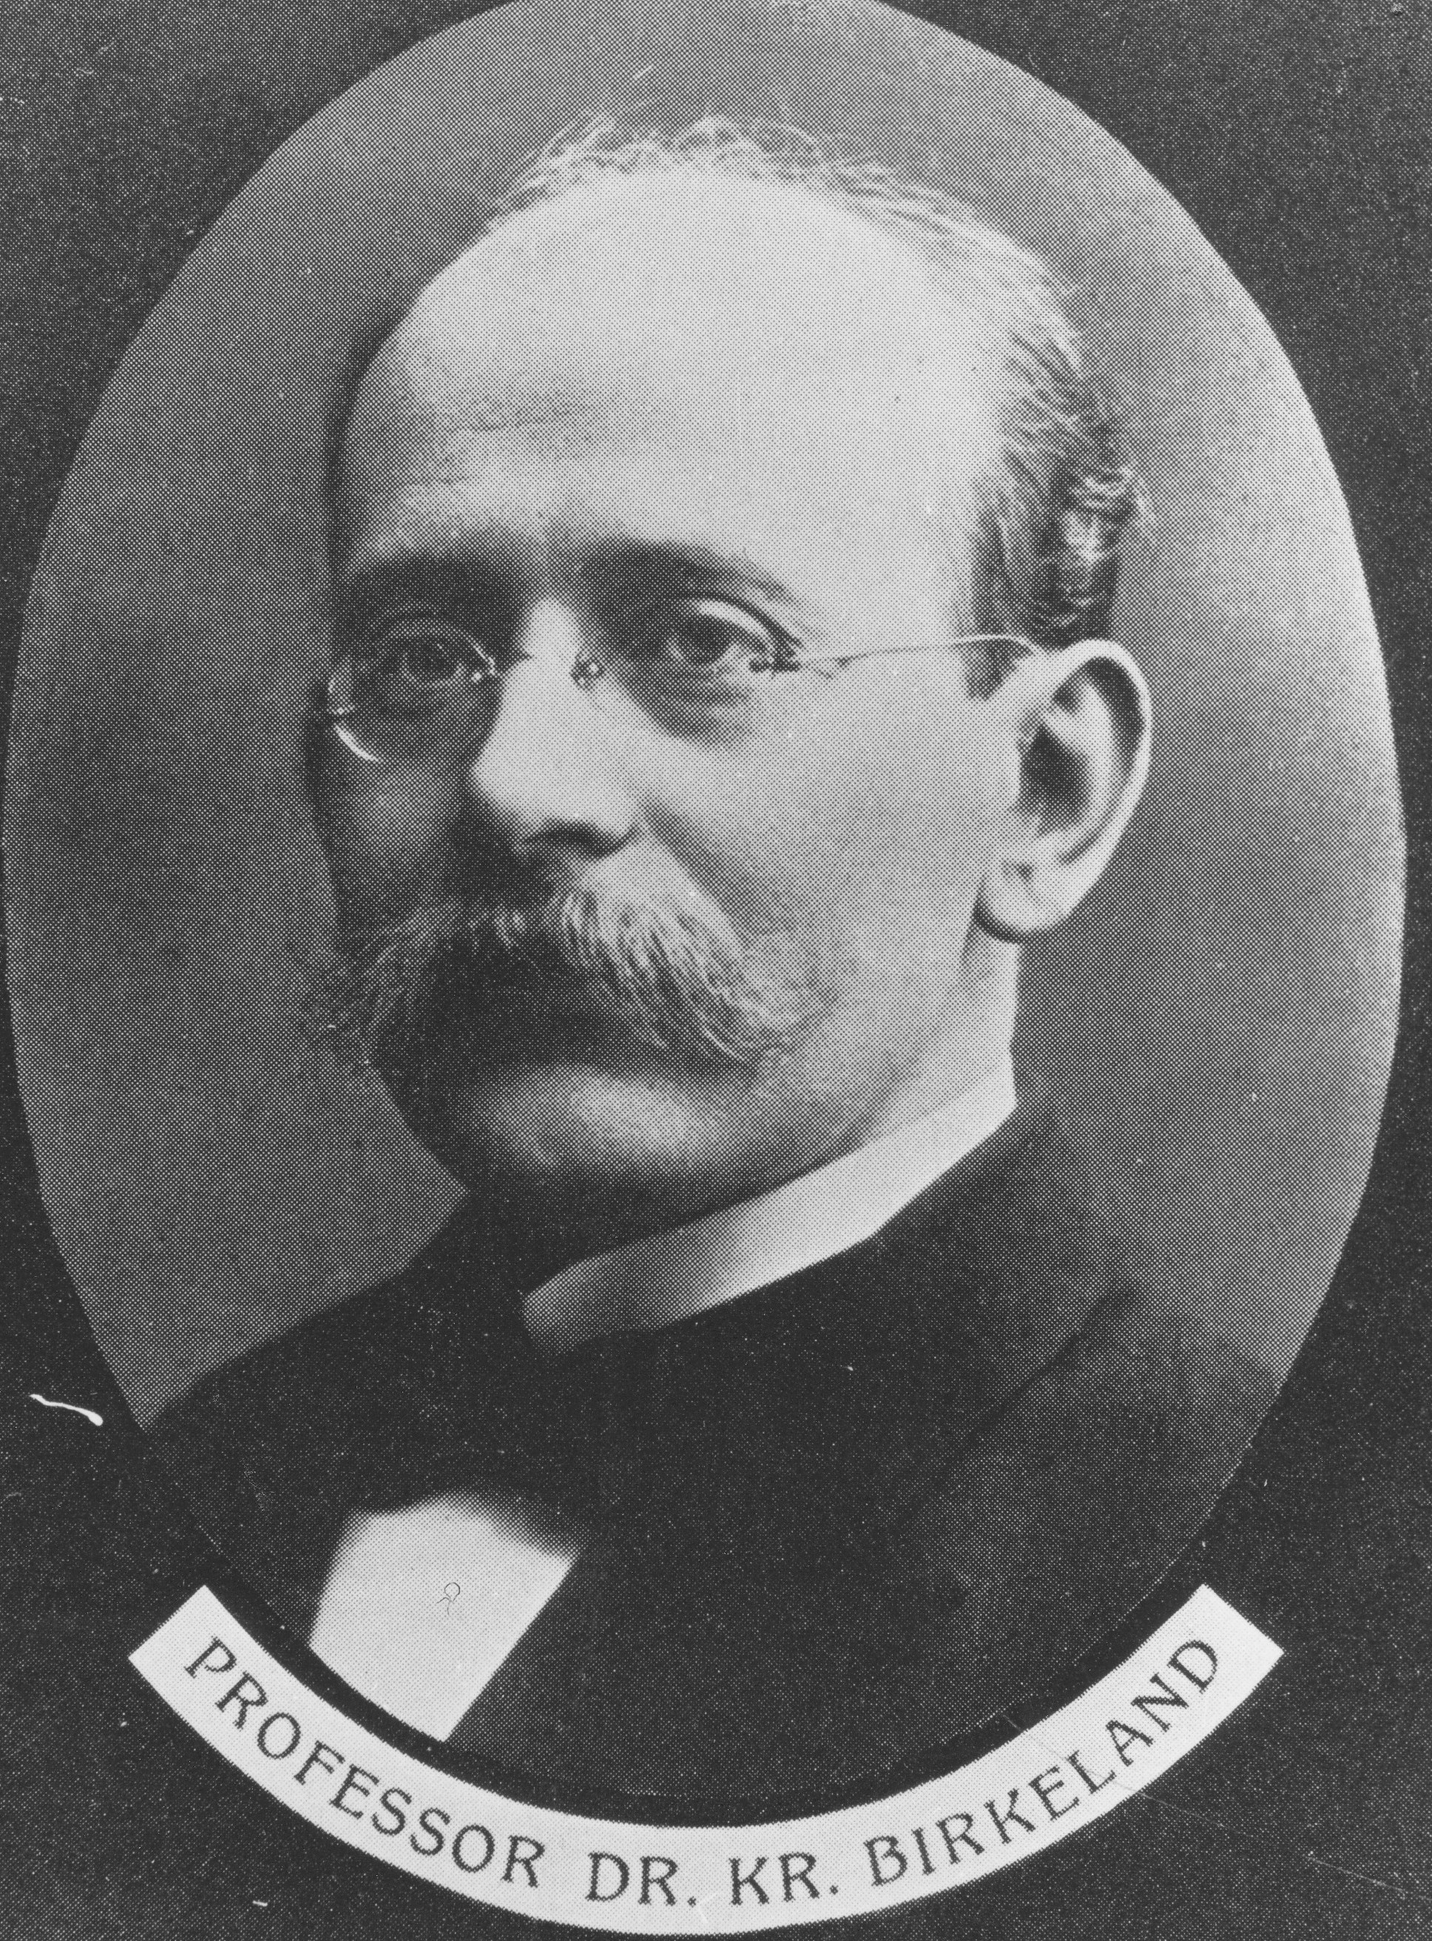
Kristian Birkeland
The First Space Scientist
by
Alv Egeland
University of Oslo, Norway

The pioneering research of Kristian Birkeland (13.12.1867 – 15.6. 1917) in geophysics contributed greatly to the study of solar-terrestrial physics. His main treatise, The Norwegian Aurora Polaris Expedition of 1902-1903, fills more than 800 pages in large format. He advanced a number of ideas that still remains central to these fields.

Birkeland published Une méthode enumérative de la géometrie and two other mathematical contributions before he was 20 years old. The papers on Poynting’s vector (1894) and the first general solution of Maxwell equations: Solution générale des équations de Maxwell pour un milieu absorbant homogéne et isotrope (1895) are his main contributions in theoretical physics.
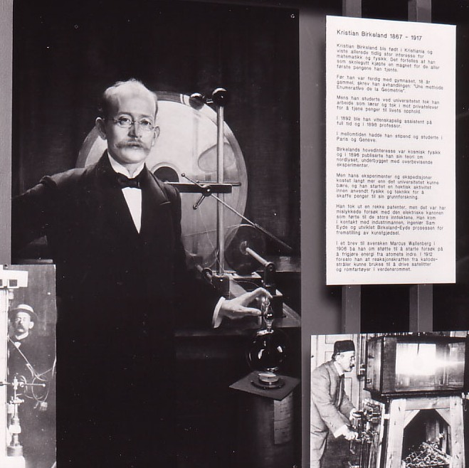
Birkeland’s work on aurora, polar storms including the global pattern of currents in the Earth’s upper atmosphere, the Sun’s particle radiation, Saturn’s rings and comets will be summarized. He carried out advanced laboratory simulations and campaigns in the arctic wilderness in light of the laws of electricity and magnetism. Although much of his work remained unrecognized for years -- only to be vindicated when in-situ measurements could be carried our -- it was truly the foundation of modern space physics. His name is connected to the Birkeland currents, auroral simulations, and disturbances in the Earth’s magnetic field.

Birkeland’s sixty patents, relating to eight different fields, stands as a living tribute to his practical genius. His first concerned an electromagnetic cannon similar in concept to a rail gun. Birkeland’s plasma torch is the foundation for the Birkeland-Eyde method for industrial nitrogen fixation, and the founding of Norsk Hydro, still modern Norway’s largest industrial enterprise. His plasma torch is used in several new technological developments.

